tshirt-back.eps

Friday, May 1st 2-5 pm

Newton County Health Dept.

812 W. Harmony, Neosho

by Orscheln’s

C:\Documents and Settings\cstokes\Local Settings\Temporary Internet Files\Content.IE5\E1I9A7XO\MCj04134740000[1].wmf



**Event Sponsored by:** **Weather cancellation:**

* Safe Kids In an event of inclement weather on
* The Alliance of Southwest Missouri day of the event, call 782-9899 for a
* Newton County Health Department recorded message or visit:

www.theallianceofswmo.org

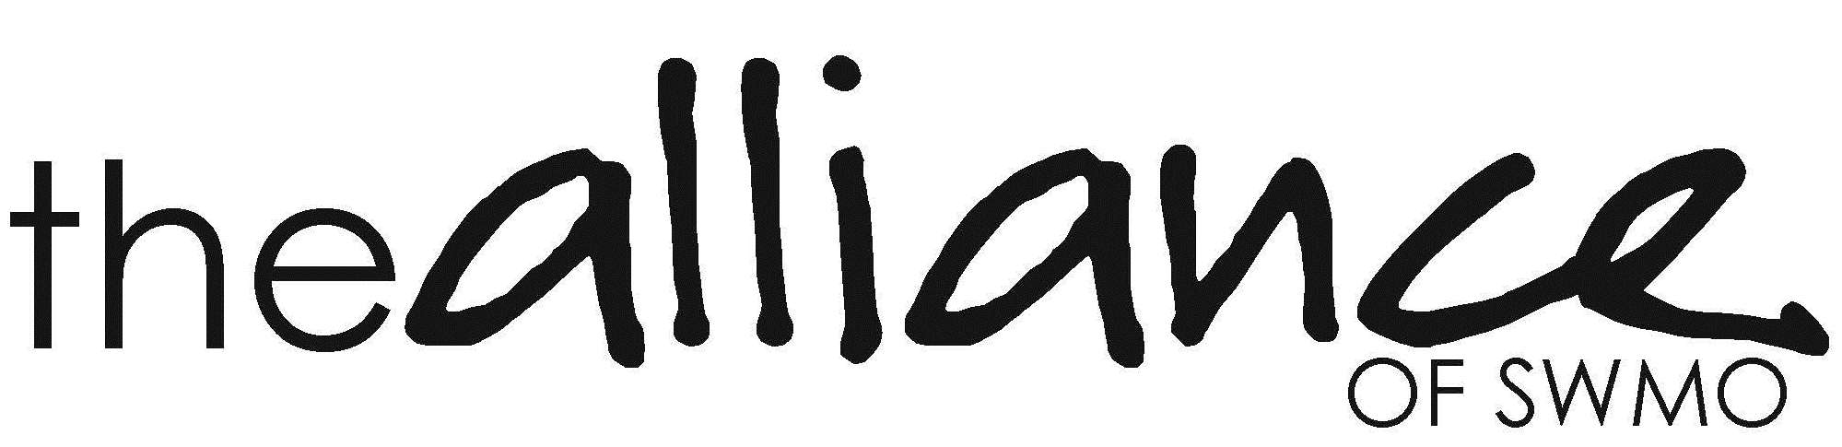

**Event Sponsored by:** **Weather cancellation:**

* Safe Kids In an event of inclement weather on
* The Alliance of Southwest Missouri day of the event, call 782-9899 for a
* Newton County Health Department recorded message or visit:

[www.theallianceofswmo.org](http://www.theallianceofswmo.org)



* **Photo ID cards**
* **Fingerprinting**
* **Safety demos**
* **Door prizes**
* **Photo ID cards**
* **Fingerprinting**
* **Safety demos**
* **Door prizes**

Friday, May 1st 2-5 pm

Newton County Health Dept.

812 W. Harmony, Neosho

by Orscheln’s