Place Stamp

Here

Newton County Drug Free Communities 209 N. Valley Street, Suite 100

Neosho, MO 64850

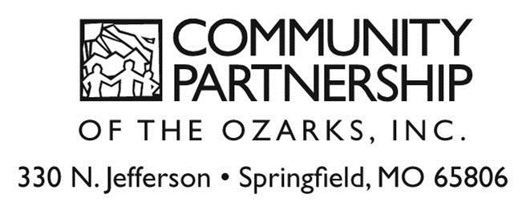

# The Newton County Community Coalition, in collaboration with Community Partnership of the Ozarks, is educating retailers and their employees on preventing sales of alcohol products to minors. We believes that local businesses are a first line defense in preventing underage drinking. These trainings, *CONDUCTED LOCALLY & FREE OF CHARGE*, are the first step toward recognizing good business practice in Newton County. In the near future all alcohol retailers who participate in this training and successfully pass random compliance checks will be recognized for their good business practices.

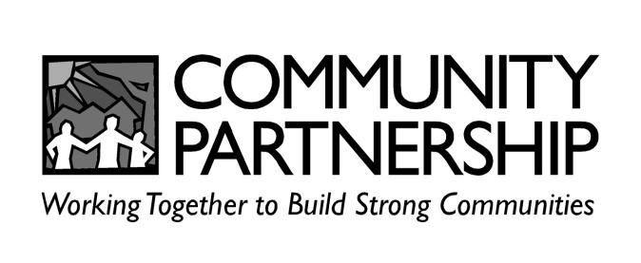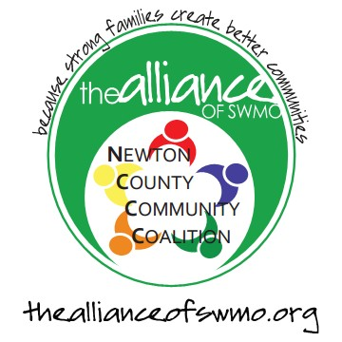

**QUESTIONS**

### Who is the training for?

The training is designed for anyone who sells alcohol products. This includes:

* Owners
* Managers
* Clerks
* Bartenders

*Owners and Managers are encouraged to attend with their employees

### What topics are covered?

Topics include:

* State Alcohol Laws
* Checking ID’s
* Detecting Fake and False ID’s
* Identifying Minors
* Compliance Checks
* And More...

### How long will the training last?

Approximately 90 minutes

### What will the training cost me?

The training is provided at no cost to you.

### Is this required?

The training is not required by law. However, if you, or one of your employees, receives a ticket from the Division of Alcohol and Tobacco Control, or another law enforcement agency, for making a sale to a minor, then you and your employees may be required to attend a training.

### Why should I or my employees go?

The training is provided to educate you and your employees about preventing the sale of alcohol products to minors. If you are found guilty of doing this, **you**, as the owner, may face up to:

* $1,000 fine per sale or license revocation (alcohol products)
* Additional civil and/or criminal charges, and **your employee**, or whoever made the sale, can face up to a $1,000 fine and/or 1 year in jail (alcohol products)

It is possible to avoid some of these penalties if you can prove your employees attended an approved training. More detailed information about different penalties and how to avoid them will be discussed during the training.

### Who is conducting the training?

Community Partnership of the Ozarks will be facilitating the training in collaboration with the Newton County Community Coalition, whose mission is to prevent drug and alcohol abuse and other risky behaviors among youth through collaboration, education, empowerment, early intervention and community transformation efforts throughout Newton County.

### Training Date/Location

Tuesday, April 28 9:30am - 11:00am

or 2:00pm - 3:30pm

### Talkington Foundation 209 N. Valley Street Neosho, Missouri 64850

**For further questions contact:**

**NEWTON COUNTY COMMUNITY COALITION**

(417) 782-9899 or 358-3270

Robin Standridge [rstandridge@theallianceofswmo.org](mailto:rstandridge@theallianceofswmo.org)

**REGISTRATION FORM:**

**Cut on dotted line and return by Friday, April 24, 2015**

Please provide us with the number of employees that will be present for trainings beginning at each of the times listed below (employees only need to attend one training):

**TUESDAY, April 28th, 2015**

Number of employees attending:

9:30am - 11:00am

or

2:00pm - 3:30pm

**Newton County Drug Free Communities**

**209 N. Valley Street, Suite 100**

**Neosho, MO 64850**

I am interested in training on how to prevent sales to minors, but am unable to attend the above trainings. Please keep me informed of future trainings in or around the area.

Please remove my name from your mailing list.

*Manager/Owner Name*

*Business Name*

*Street Address*

*City, State, Zip*

## ( )

*Phone Number*