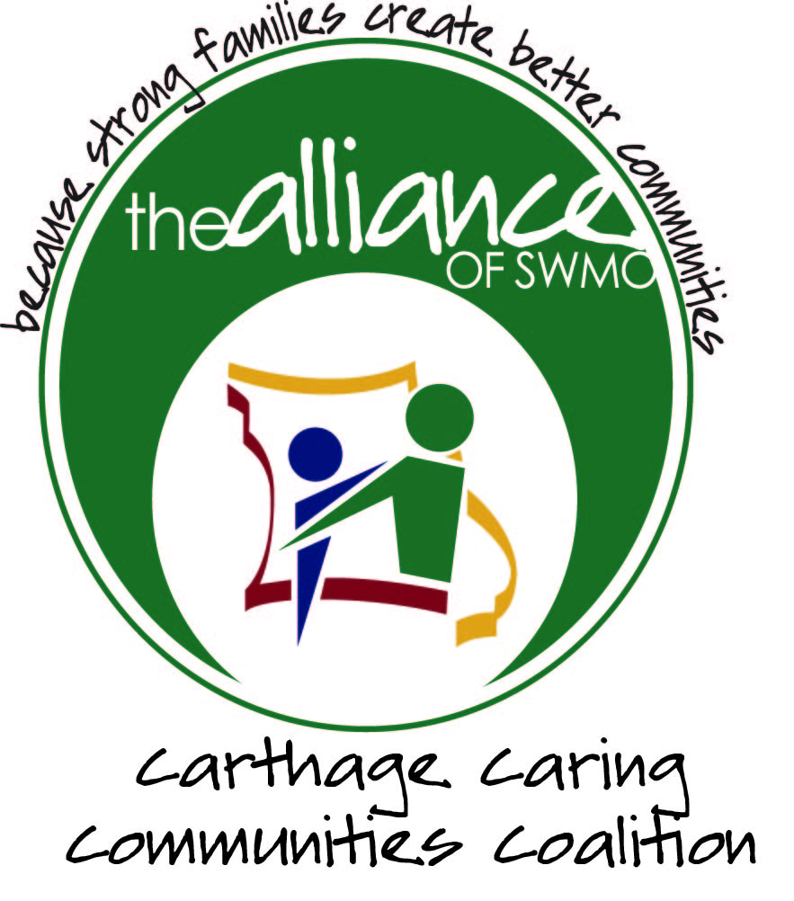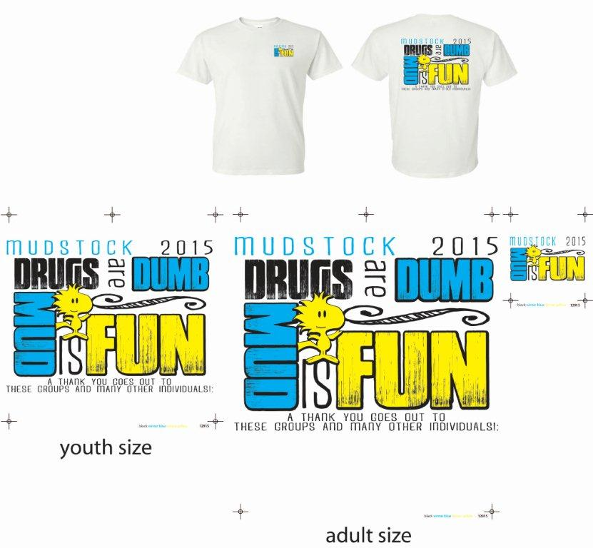

Saturday, June 6th, Noon – 3 pm

A free event for kids,   
held behind Walmart, Carthage

**To take part in Mudstock 2015** **complete and bring this form**. Please read carefully.

|  |  |
| --- | --- |
| Participant Name(s):  (Please Print) |  |
| Age(s): |  |

My family and I hereby waive and release the City of Carthage, the Alliance of Southwest Missouri, and all agents thereof involved and supporting organizations from claims for damage and/or injuries incurred while participating in Mudstock. I hereby indicate I am the guardian/responsible adult for the participants listed.

PERMISSION TO USE IMAGE/TESTIMONIAL DATA  
  
I give The Alliance of Southwest Missouri, its employees, designees, agents, independent contractors, legal representatives, successors and assigns, and all persons or departments for whom or through whom it is acting, the absolute right and unrestricted permission to take, use my name, testimonial and biographical data and/or publish, reproduce, edit, exhibit, project, display and/or copyright photographic images or pictures of me or my child(ren), whether still, single, multiple, or moving, or in which I (they) may be included in whole or in part, in color or otherwise, through any form of media (print, digital, electronic, broadcast or otherwise) for art, advertising, recruitment, marketing, fund raising, publicity archival or any other lawful purpose.

I waive any right that I may have to inspect and approve the finished product that may be used or to which it may be applied now and/or in the future, whether that use is known to me or my child(ren) or unknown, and I waive any right to royalties or other compensation arising from or related to the use of the image or product.

I release and agree to hold harmless The Alliance of Southwest Missouri, its Board of Directors, officers, employees, agents, nominees, departments, and/or others for whom or by whom The Alliance of Southwest Missouri is acting, of and from any liability by virtue of taking of the pictures or using the testimonial/biographical data, in any processing tending towards the completion of the finished product, and/or any use whatsoever of such pictures or products, whether intentional or otherwise.

I certify that I am at least 18 years of age (or if under 18 years of age, that I am joined herein by my parent or legal guardian) and that this release is signed voluntarily, under no duress, and without exception of compensation in any form now or in the future.

I give the participant named above permission to attend and participate in this activity. Important: I understand that if my child is 12 years of age or younger, that I must remain on the Mudstock grounds during their participation. I understand that my child is required to **bring and wear a shirt, shorts, socks and shoes (no sandals) in order to participate in this event.**

|  |  |  |
| --- | --- | --- |
| Parent or Guardian Name: (Please Print) |  | |
| Signature: |  | Date: |
| Emergency Contact # |  | |
| Email address: |  | |

## These groups are significantly contributing to this event: The Alliance of Southwest Missouri, The Carthage Police Dept., the Missouri Army National Guard, the Carthage Fire Dept., Carthage Parks and Recreation Dept., Mercy Ambulance-Carthage, Carthage Caring Communities, Teen Scene Council, Fair Acres Family YMCA, The Dug Out, Wells Enterprises, Forest Park Baptist Church, Southwest Missouri Bank, Boomer Sooner, Alumbaugh Construction, and Race Brothers Farm and Home Supply.

## THANKS to all these groups and many additional individuals!